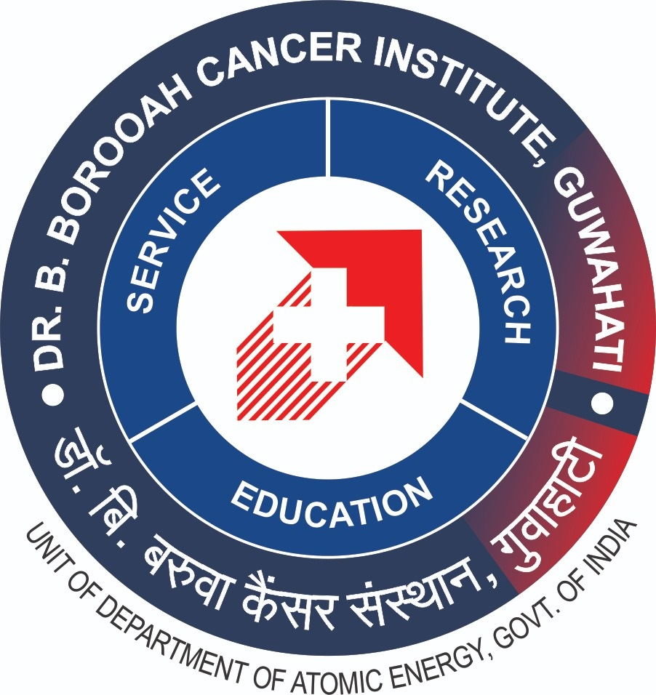
(Application Form)
Title of the research project:
Name of the applicant:
Names of Guide and Co-Guide:
Email address
Postal address:
Phone number:
City
Institution/Affiliation:
Research at BBCI or in Collaboration: BBCI/Collaborative
If Collaborative, BBCI Co-Investigator:

- Synopsis of the Research Project (Not more than 1000 words)
Aims/Objectives:
Material and methods:
Subject group:
Disease:
Duration of study:
Scope and impact
- Write an essay to describe why the research project should be considered for the award? (not more than 300 words)

Enclosures:
- Letter of recommendation from Guide, Supervisor, or institutional head in letter head
- Copy of certificate of University registration (for PhD applicants)
- Copy of approval certificate of ethics committee/IRB
- Signature in all pages of Rules and Regulations
Awards Management may not consider / be responsible/ held liable for application forms which are in incorrect format / without declaration / received late / corrupt etc
*Hard Copy by post to (Deepika Phukan Oncology Research Grant Award must be mentioned on envelope cover)
The Director, Dr B Borooah Cancer Institute, A K Azad Road, Gopinath Nagar Guwahati 781016 (Assam)
Last Date of Receipt of Application: 31.08.2024
*Awards Management may not consider / be responsible/ held liable for application forms which are in incorrect format / without declaration / received late / corrupt etc
Rules and Regulations
Deepika Phukan Oncology Research Grant Award of Dr B Borooah Cancer Institute

PREAMBLE
Deepika Phukan was an epitome of elegance, dignity, and grace. Born in 1935 to Kamala and Surendra Nath Bezbarua, she was one of the sisters of Padmashree Dhiren Bezbarua. Educated in Chennai and Assam, she was a gold medalist in education from Guwahati University. Later, she accompanied her husband Satyen Phukan (former Chairman of NEEPCO) to the UK in the 1960s, where she taught at the Notre Dame High School. On here return from the UK, she joined as a lecturer in St Mary’s College, Shillong. After retirement from services, she along with her husband settled in their Guwahati residence. The Award has been instituted in her name by her husband Satyen Phukan.

RULES & REGULATIONS
1. Definitions
Award: Late Deepika Phukan Oncology Research Grant Award of Dr B Borooah Cancer Institute will be referred to as the “Award”
Applicant/Nominee: An individual that sends in an application to participate in the Award as per these rules
Award Management: The committee headed by the Director of Dr B Borooah Cancer Institute, Guwahati as its Chairman is responsible for the conduct of the “Award”
Jury: Individuals appointed by Award Management to evaluate the applications

2. Objective of the Awards
To promote cancer research a grant of INR one lakh each year for 3 consecutive years (subject to satisfactory progress of research work) will be provided to young meritorious and promising scholars for research in the field of cancer. Researchers will be selected every three years for the grant. Submission of utilization certificate is mandatory under the following heads:
Consumables, travel (to workshop and conference), publication, and contingency. Financial disclosure of additional funding is must by the applicant at the time of receiving the Grant and non-utilized funds shall be refunded (An MoU will be signed in this regard)

3. Award categories and definitions
The Award and the parameters for evaluation may be changed / modified / split / merged / increased or cancelled by the Award Management and / or Jury from time to time. The decision in this regard will be final and non-contestable. The Award management will not entertain any queries in this regard.

4. Call for application & participation
The call for entries for the Award will be announced on the BBCI website and through local newspaper announcement. The Award Management and / or Jury have the right to reject any application if false/misleading information is found to have been submitted in the nomination process.

5. Eligibility Criteria
The Grant is for citizens of India pursuing PhD in basic or translational cancer research from any UGC recognized University or post-doctoral research or MD/MS in-service researcher in recognized institutions where the research is done in collaboration with Dr B Borooah Cancer Institute (BBCI), Guwahati or at BBCI. Preference will be given to applicants with proposals in translational and clinical research. The Award Management Committee holds the right to disqualify any application which does not meet the eligibility criteria without assigning any reason whatsoever.

6. Receipt of entries
Participation in the Award in any manner will be construed as an acceptance to the Rules and Regulations stated herein. An applicant can apply for the Award by submitting the completed nomination/application form in the following manner:
- In the nomination form, applicants should fill in the following details
Title of the research project
Name of the applicant
Names of Guide and Co-Guide:
Email address
Postal address
Phone number:
City
Institution/Affiliation
- Synopsis of the Research Project (Not more than 1000 words)
Aims/Objectives
Material and methods
Subject group
Disease
Duration of study
Scope and impact
- Write an essay to describe why the research project should be considered for the award? (not more than 300 words)

- Letter of recommendation from Guide, Supervisor, or institutional head in letter head
- Copy of certificate of University registration (for PhD applicants)
- Copy of approval certificate of ethics committee/IRB
Awards Management may not consider / be responsible/ held liable for application forms which are in incorrect format / without declaration / received late / corrupt etc
7. Screening of received nomination/application forms
Award Management will appoint experienced personnel to screen application forms to ensure adherence to the eligibility criteria and rule and regulations.
8. Completeness of entries/disqualification
Entry forms must be filled in English only. Nomination/application forms that are received incomplete in any manner may be disqualified by the Award Management. Applications may be disqualified if they do not follow any of the rules & regulations stated here-in. Disqualification of entries received is at the sole discretion of Award Management, on a case by case basis.
9. Application Information
If at any time, any information provided by any applicant/nominee is found to be false/misleading/incorrect in any manner, then the applicant/nominee will not be permitted to continue participation in the Award. The Award Management has the right to ask for proof of information provided. If such a request is made and the applicant/nominee does not comply, the applicant/nominee could be disqualified from participation at the Award.
10. Determination of Winner
The assessment will be conducted by a five-member jury formed by the Award Management Committee for the purpose. The method of selection will be through review of project proposals (10 marks), work done (5marks), and on the basis of a presentation (5 marks) by the applicant. Total score will be 100 and each member will assess for 20 marks. The jury may also decide, in order to adhere to the standards of the award that there could be no winner.

11. General
Applicants/nominees understand and agree that merely by applying for the Award does not entitle the applicant/nominee to any other form of consideration. Decision of Award Management on all matters is final and binding on all applicants/nominees and no correspondence will be entertained on the same. Annual report (SAT) must be presented at the end of year’s receipt of award for next year’s fund to be released. In case of unsatisfactory performance, the award may be withdrawn midway and there will be fresh call for applications.

12. Acknowledgement
Awardee shall acknowledge the funding support as Deepika Phukan Oncology Research Grant Award of Dr B Borooah Cancer Institute in the thesis/dissertation and in scientific research publications where findings of the research are published.
13. Rules
The Award Management reserves the right to withdraw or amend the terms of the Award at any time, and does not take the responsibility for any loss or damage that any person / organization / Applicant / Nominee may suffer as a result of the Award being withdrawn or its terms amended. The filing of the nomination form by the nominees/applicants would signify their acceptance of these Rules and Regulations.
14. Jury Members
The award management shall select jury and frame rules for the jury from time to time

15. Amendment or rules
This shall be decided by the Award Management in its meeting

